WHO AT MY DOOR IS STANDING?

In the year 1876, Mary B.C. Slade wrote the following lyrics to one of our most penetrating hymns, "What at the door is standing, Patiently drawing near, Entrance within demanding? Whose is the voice I hear?" The chorus goes onto say, "Sweetly the tones are falling: Open the door for me! If thou wilt heed my calling, I will abide with thee."
We recognize that Mary Slade was no doubt inspired to write these words from what she read in Revelation 3:20. The text sets forth a beautiful mind picture. "I" is Christ. The "door" is to the house of man's heart. The proprietor is man's will, and Christ is to be the guest.
John writes, "Behold, I stand at the door and knock." Christ is asking for admittance into our hearts and lives. He has a right to ask because of His love, His sacrifice, His promises in the Gospel. Every influence heaven can exert is brought to bear on man so he will "hear my voice."
"“If any man": The Gospel is for all. Christ wants no one excluded, (2 Peter 3:9), He is no respecter of persons (Acts 1:34).
"Will hear": WE must hear Christ and listen to no one else, (Mt. 17:5; Jn. 14:6; Acts 4:12). Faith comes by hearing (Rom. 10:17).
"My voice": We are only to hear man when he speaks the words of Christ. Many are deceived by men (1 Jn. 4:1).
"And open": Man has to do the opening. Jesus is not going to force His way inside. Man is a free agent, and God respects man's will. But man needs to know he is responsible for the choices he makes and will be held accountable for them in Judgment.
"I will come In and sup": A sweet communion awaits the sinner when he is brought into a covenant relationship with Christ.
But Jesus will only stand and knock for so long. Don't ignore His patient pleading! J.D. Conley, chandler church of Christ, Chandler, OK

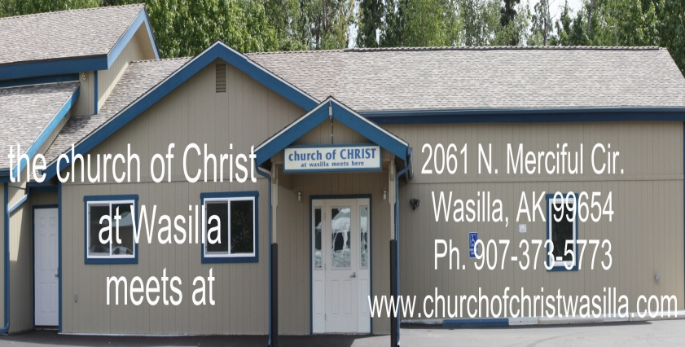

Sunday Wednesday
Bible Class: 10am Bible Study: 7:00 pm
Worship: 11am
Evening: 6pm
April 23rd, 2017
Visitors Always Welcome; Members expected
“the gospel of Christ is the power of God unto salvation” Romans 1:16
God’s Plan of Salvation
- Hear………………………….…………Romans 10:17
- Believe…...…………..Mark 16:16; Hebrews 11:1-6
- Repent………..……..Acts 2:38; II Corinthians 7:10
- Confess……………..Romans 10:9, 10; Mt. 10:32,33
- Be Baptized………………...Mark 16:16; Acts 22:16
- Arise & walk in newness of life…….…Romans 6:4
- Elders Phone Email:
- Ed Maxwell: 907-373-5583 ed@churchofchristwasilla.com
- Hans Nicholson: 907-230-2969 hnichs@gmail.com
- Deacons
- Joe Murdock 907-715-0089 montana2189@hotmail.com
- Wayne Ezell 907-414-0613 nytman09@yahoo.com
CASTLES MADE OF SAND

There is little as charming, well-planned, and skillfully made as a sand castle. Children of every age enjoy the hours of shaping sand into the grand palaces, which exist only in the faraway lands of their minds. Along with this recreation comes a life lesson. A sand castle, for most, immediately calls to mind the thought of that which is temporary. Too many toddlers’ tears have been shed watching the tide take away the fruit of their tedious toils. With full knowledge of this adults still have an insatiable attraction towards sand castles. Every year thousands or more enthusiasts converge upon Imperial Beach, California, for the U.S. Open Sandcastle Competition. There they build some of the most spectacular sand castles you could ever imagine. Exact replicas of the greatest architectural masterpieces built by man, and others that could only be built of dreams and sand. While those in the competition may win prizes with skill exceeding child’s play, they still are only making sand castles. Unfortunately, so many have approached life forgetting the lessons they learned. While one may become proficient and skillful at many things, where is the lasting benefit? Someone may build something beautiful and bring great joy to themselves and others, what real value does it have? The tide of death is one that all men should see approaching (Heb. 9:27). As some learn of such an end, they find it almost unbearable to work towards anything. The faithful, on the other hand, do not find such torment as the day approaches. The psalmist said, “Yea, though I walk through the valley of the shadow of death, I will fear no evil: for thou art with me; Thy rod and thy staff they comfort me” (Psa. 23:4). The key to such confidence lies in a rock solid faith in Christ and His Word. Jesus said, “Whosoever heareth these sayings of mine, and doeth them, I will liken him unto a wise man, which built his house upon a rock: And the rain descended, and the floods came, and the winds blew, and beat upon that house; and it fell not: for it was founded upon a rock. And every one that heareth these sayings of mine, and doeth them not, shall be likened unto a foolish man, which built his house upon the sand: And the rain descended, and the floods came, and the winds blew, and beat upon that house; and it fell: and great was the fall of it” (Mat. 7:24-27).
Building one’s house upon Christ is a sure way to ensure that the tempests of life will not overcome the structure. In these verses there is great similarity to the lessons learned from building sand castles. There is that which is unstable, situated in such a way that it is sure to fail. Wherein is the security? A denomination, built by men, is not built on a solid foundation (1 Cor. 3:11; Mat. 16:16-18). A life of successful business is one of fleeting glory (Luke 12:15-21). The goal of most is a merry heart, but without Christ that merriment will end like the smile on a child’s face when the first wave crashes over the seemingly solid walls of the sand fort. On the other hand, there is Christ and His Word. When one does what Christ commands he is building upon sure ground able to withstand anything. Geoff Litke

~~~~~~~~~~~~~~~~~~~~~~~~~~~~~~~~~~~~~~~~~~~~~~~~~~
Take Life in Bites

I read once that the first bite of food, no matter the item, is the best taste. Each bite after dims in great flavor as your taste buds get used to is. I love going to buffet’s and I take one small spoonful of each thing and sit and savor the flavors. My plate looks like a sampler. So sample life one bite at a time. Too much of something dulls the excitement and flavor. Remember the days of youth. How exciting things were. Rekindle that as a child. We don’t have to have everything but we can feel like we do by enjoying what we have.
~~~~~~~~~~~~~~~~~~~~~~~~~~~~~~~~~~~~~~~~~~~~~~~~~~
Our Family News
Pray For: Cassie Douthitt, Logan’s grandpa
Traveling/Working: Christian Larson, Cory Reed, the Churchill’s, Logan Decker
Bible Study: Due to graduation ceremonies, May 10th Bible study will be moved to May 9th at 7pm.
Radio Program: Listen to “Searching the Scriptures”, our weekly radio program, Sundays at 9am, on 99.7 FM.
Today’s Scripture: “For the wages of sin is death; but the free gift of God is eternal life in Christ Jesus our Lord.” Rom. 6:23 (1901 ASV)
Today’s Proverb: “Withhold not good from them to whom it is due, When it is in the power of thy hand to do it.” 3:27 (1901 ASV)

Attendance last Sunday: 64

